**Response for Assignment 5.2**

Below screenshot shows the output of the program which will generate all combinations of outcomes of 3 lists which have different words

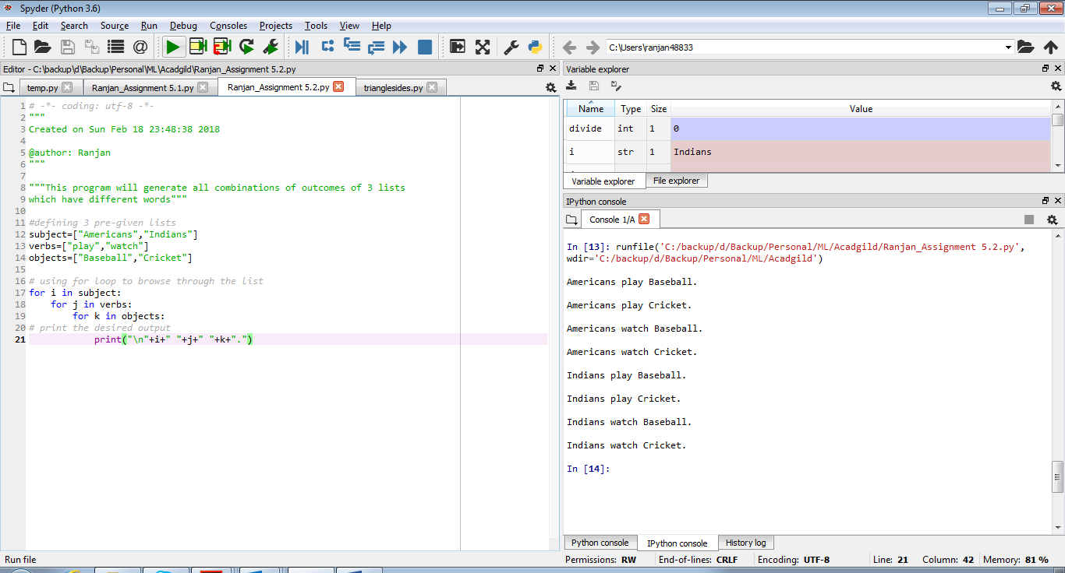

**Source Code**

#defining 3 pre-given lists

subject=["Americans","Indians"]

verbs=["play","watch"]

objects=["Baseball","Cricket"]

# using for loop to browse through the list

for i in subject:

for j in verbs:

for k in objects:

# print the desired output

print("\n"+i+" "+j+" "+k+".")